TRYHACKME LAB WRITEUP
Intro to Logs
Platform | TryHackMe
Room | Intro to Logs
Room URL | https://tryhackme.com/room/introtologs
Completion date | 02/11/2026

1. Objective
The objective of this room is to understand logs as historical records of system and application activity, explore common log types and formats, learn how logs are collected and centralised, and practise basic log management and analysis techniques. The practical scenario uses the SwiftSpend Financial web server environment to investigate activity recorded in different log sources.

2. Learning objectives
- Understand why logs are important for identifying and investigating potential threats.
- Recognise common log types, formats, and logging standards.
- Understand log collection, management, centralisation, storage, retention, and deletion.
- Learn the purpose of rsyslog and logrotate.
- Understand the stages and tools used in log analysis.
- Use log evidence to investigate activity in a practical scenario.

3. Concepts covered

3.1 Logs as historical evidence
A log is a record of an event that occurred in a system, application, or device. A log entry commonly contains a timestamp, the system or application that generated it, the event type, and additional details such as a username or IP address. Individual entries may appear insignificant, but correlating records from multiple sources can help answer what happened, when it happened, where it happened, who was involved, whether the action succeeded, and what the result was.

3.2 Common log types
Log type | Typical information
Application logs | Application status, warnings, errors, and user actions.
Audit logs | Activities relevant to accountability and compliance.
Security logs | Logins, permission changes, firewall activity, and security events.
Server logs | System, event, error, and access records generated by servers.
System logs | Kernel activity, boot sequences, system errors, and hardware status.
Network logs | Network traffic and connection-related events.
Database logs | Database queries, updates, and other database activity.
Web server logs | HTTP requests, requested URLs, client details, and response codes.

3.3 Log formats and standards
A log format defines how data is organised and encoded. The room groups formats into three broad categories:
- Semi-structured: predictable elements mixed with free-form text. Example: Syslog messages.
- Structured: records follow a defined field layout. Examples: CSV, TSV, JSON, W3C Extended Log Format (ELF), and XML.
- Unstructured: free-form text that may require more interpretation or custom parsing.
Standards and guidance introduced in the room include:
- Common Event Expression (CEE).
- OWASP Logging Cheat Sheet.
- Syslog Protocol.
- NIST Special Publication 800-92.
- Cloud logging services and organisational logging standards.

3.4 Log collection, management, and centralisation
- Collection: identify log sources and select a suitable collector to gather records from servers, applications, databases, and network devices.
- Time synchronisation: use Network Time Protocol (NTP) so timestamps from different systems can be compared accurately.
- Management: store logs securely, organise them, back them up, and review them periodically.
- Centralisation: forward logs to a central platform such as Splunk or the Elastic Stack for searching, monitoring, and correlation.

3.5 rsyslog practical
The room demonstrates using rsyslog to direct sshd messages into a dedicated file. The example destination is /var/log/websrv-02/rsyslog_sshd.log.
Configuration example from the room:
$FileCreateMode 0644
:programname, isequal, "sshd" /var/log/websrv-02/rsyslog_sshd.log
Commands and actions:
- Check the service: sudo systemctl status rsyslog
- Create/edit the configuration file: sudo nano /etc/rsyslog.d/98-websrv-02-sshd.conf
- Restart the service: sudo systemctl restart rsyslog
- Generate or wait for SSH activity, then inspect the configured output file.
SOC relevance: separating SSH messages into a dedicated file makes authentication activity easier to review and forward to a central log platform.

3.6 Storage, retention, deletion, and logrotate
Log storage decisions depend on security, access, capacity, cost, compliance, retention, and disaster recovery requirements. The room describes hot storage as the most readily accessible recent logs, warm storage as older but still accessible records, and cold storage as archived data intended for less frequent retrieval. Log deletion should follow a defined policy, and important records should be backed up before deletion.
The room introduces logrotate as a utility that manages log files through rotation, compression, and removal according to configured policies. This helps prevent log files from growing without control.

3.7 Log analysis process and tools
Stage | Purpose
Parsing | Break raw log data into understandable fields.
Normalisation | Standardise parsed data into a consistent format.
Sorting | Order records by time, source, severity, or another field.
Classification | Group records by event type, source, or severity.
Enrichment | Add useful context such as user, geographic, or threat-intelligence information.
Correlation | Connect related records to identify patterns and relationships.
Visualisation | Present information in charts, graphs, or dashboards.
Reporting | Summarise findings for analysts and stakeholders.
Tools mentioned in the room include:
- Linux utilities: cat, grep, sed, sort, uniq, and awk.
- Integrity checking: sha256sum.
- Windows tools: EZ-Tools and Get-FileHash.
- Centralised analysis: Splunk and Elastic Stack.
- Log viewing: the room's Log Viewer web interface.

4. Practical activities and room questions
Record answers from your own running TryHackMe machine. The machine-specific values below are intentionally left blank because they must be verified from your lab instance.

Task 4 – rsyslog collection questions
1. Username repeatedly appearing in /var/log/websrv-02/rsyslog_sshd.log: [Verify and enter your result]
2. SIEM-02 IP address from /etc/rsyslog.d/99-websrv-02-cron.conf: [Verify and enter your result]
3. Command executed by root in /var/log/websrv-02/rsyslog_cron.log: [Verify and enter your result]

Task 6 – log analysis questions
1. Error shown for /var/log/websrv-02/rsyslog_cron.log when selecting filters in the raw Log Viewer: [Record the exact error shown by your lab]
2. What is the process of standardising parsed data into a more easily readable and queryable format?
Answer: Normalisation. It converts parsed records from different sources into a consistent structure so that fields can be compared, searched, and analysed more easily.
3. What is the process of consolidating normalised logs to enhance analysis of activity related to a specific IP address?
Answer: Correlation. Related records are connected across log sources using common fields such as an IP address and timestamp. Filtering or grouping the consolidated records by the IP address helps an analyst examine the activity associated with that address.

5. Evidence and screenshots

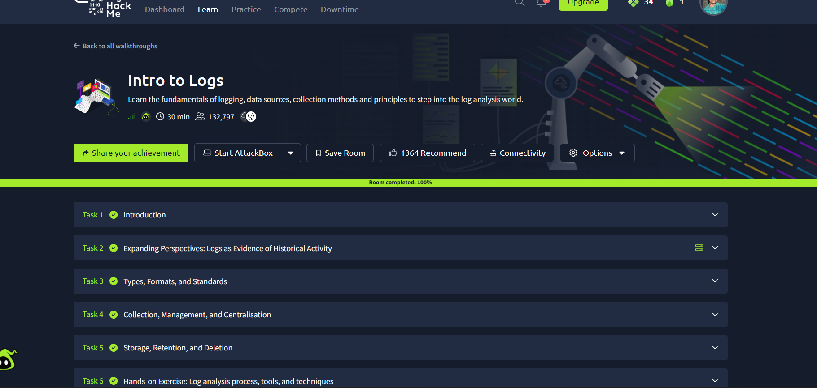6. SOC analyst relevance
- Logs provide historical evidence for reconstructing suspicious activity.
- Centralised collection makes it easier to investigate events across multiple systems.
- Time synchronisation helps create a reliable incident timeline.
- Retention and access controls help preserve useful evidence.
- Parsing, normalisation, enrichment, and correlation make large log datasets easier to investigate.
- Hashing collected logs can help verify that evidence has not changed during handling.

7. Key takeaways
- Logs record activity from systems, applications, servers, and network devices.
- Log formats include semi-structured, structured, and unstructured records.
- rsyslog can route selected messages into dedicated log files.
- Logrotate helps manage file size through rotation and compression.
- Hot, warm, and cold storage support different retention and access needs.
- Log analysis uses parsing, normalisation, sorting, classification, enrichment, correlation, visualisation, and reporting.

8. Conclusion
This room demonstrates how logs act as historical evidence and how effective collection, centralisation, storage, and analysis improve security monitoring. The rsyslog activity shows how selected SSH messages can be routed to a dedicated file, while the log analysis section introduces techniques for preparing and correlating records. These skills help SOC analysts investigate suspicious activity and build a clearer timeline from multiple sources.
Week 3 | SOC Analyst Internship

